**CSE 6331**

**Final Project Report**

**Team Details:**

1. **Name: Harsh Sharma, Student Id: 1001642088**
2. **Name: Shitiz Kumar Aggarwal, Student Id: 1001669578**

**Section Assigned:** UTA Section C

**REPORT OUTLINE**

1. INTRODUCTION…………………………………………………………3
2. SYSTEM AND SOFTWARES USED………………………………......3
3. FIRST MILESTONE DESCRIPTION……………………...……………4
4. FINAL MILESTONE DESCRIPTION……………………………………7
5. REFRENCES……………………………………………………………..17
6. APPENDIX………………………………………………………………..

**INTRODUCTION**

In this project The University of Texas at Arlington map is improved. The purpose of this project is to learn how to extract kml files from Google Maps and convert them to shapefiles. Then those shapefiles were used by Spatial Database tools such as ArcGIS which is used by us for this project.

For the First Milestone we used Google Earth Pro to edit our kml file of section ‘c’. We have also used QGIS software to analyze the shape files.

For the Final Milestone of the project ArcGIS is used which is a spatial database tool on which queries can be performed.

**SYSTEM AND SOFTWARES USED**

**Systems Used:** MAC-OS, Windows 7 CORE i5

**Softwares Used:** QGIS 3.6, Google Earth Pro, Visual Studio and

ArcGIS Pro

**FIRST MILESTONE DESCRIPTION**

* We read the project description and analyzed the UTA Map given in the project description document.
* We noted down all the buildings, parking lots, paths and points given in the Section C of UTA Map.
* Here, Polygons represent buildings and open spaces.
* Linestring represent the roads (i.e., pathways from one point to another) for our Section C of UTA Map.
* Points represent the building entrance, shuttle stop and parking entrance for Timber Brook Apartment which can be understood clearly by seeing on Google Earth.

**Software Used and changes done to the given kml file:**

* We used **Google Earth Pro** to edit our given kml file of section C which was assigned to us by the professor.
* In our kml file there was an open space in the parking lot which was not covered. So, we made a polygon to cover that in our kml file of Section C.
* We added the layer names for the various buildings, lines and points as defined by the standard posted by TA in class.
* Now our edited kml file is more accurate and is based on the specifications expected.
* We have also used **QGIS software** to analyze the shape files of our updated kml file and QGIS file has also been updated.
* We are attaching the screenshots of the Google Earth Pro before and after the changes were made and also screenshot of QGIS file is also attached.
* Screenshot of Google Earth Pro before the changes were made.

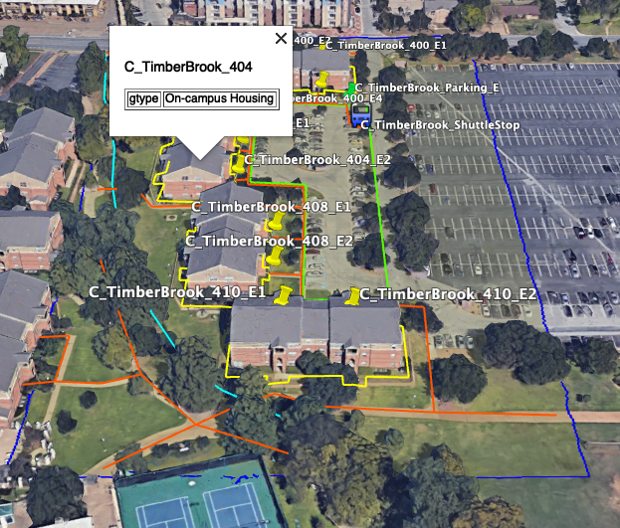

* Screenshot of Google Earth Pro after the changes were made and it can be seen that Layer names are added and Open Space is added.

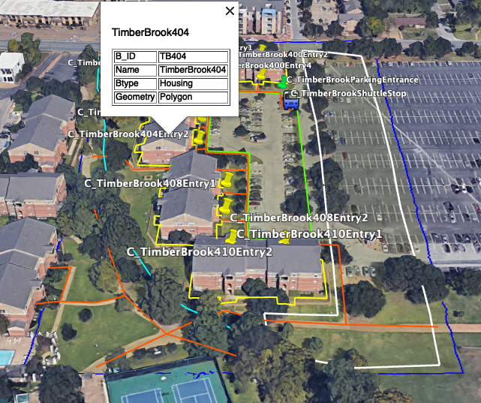

* Screenshot of QGIS file before the changes were made.

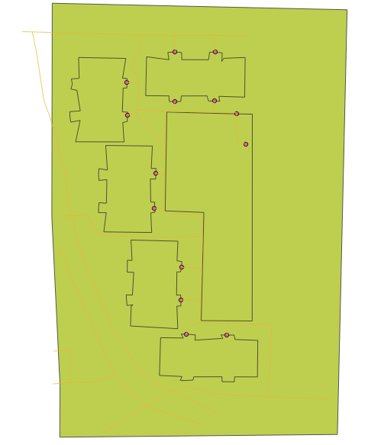

* Screenshot of QGIS file after the changes were made.

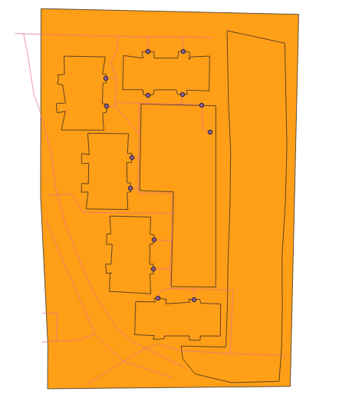

**FINAL MILESTONE DESCRIPTION**

**QUERY 1**

Choose a building (by choosing it from a list (pull-down menu) of building names), and display the building requested in a highlighted color on the map.

**SOLUTION**

* Firstly, we select a building in ArcGIS tool as shown in screenshot. The building selected is University Centre.

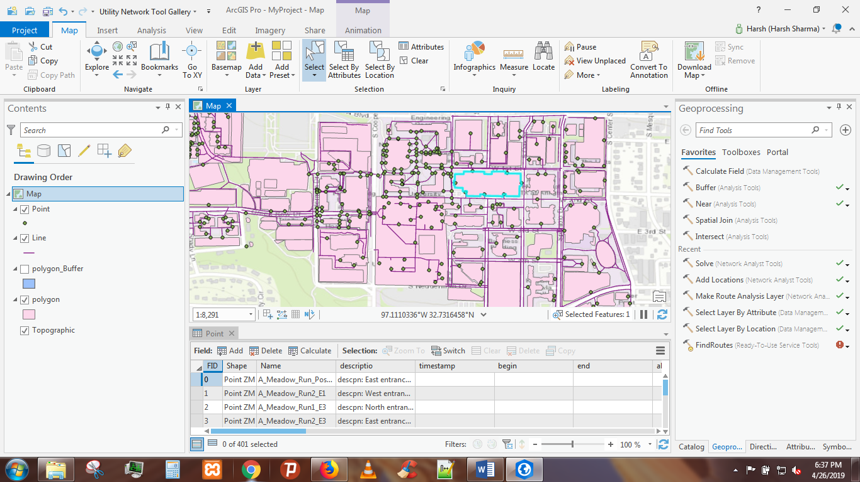

* After selecting the building we would click on select by attribute from above menu in the tool to write the query.

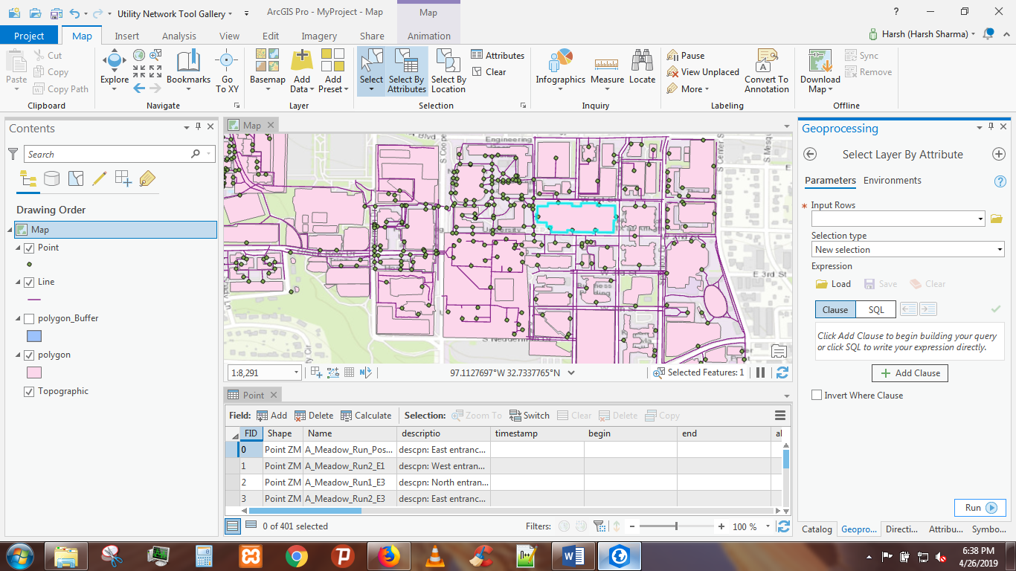

* This is what we view after clicking Select By Attributes tab.

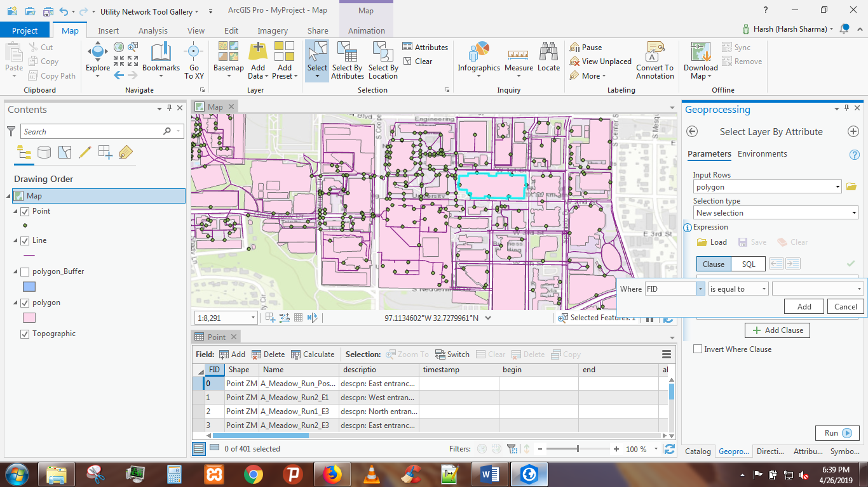

* We requested the building to be highlighted in the map is Mavericks Activity Centre which can be viewed in the screenshot.

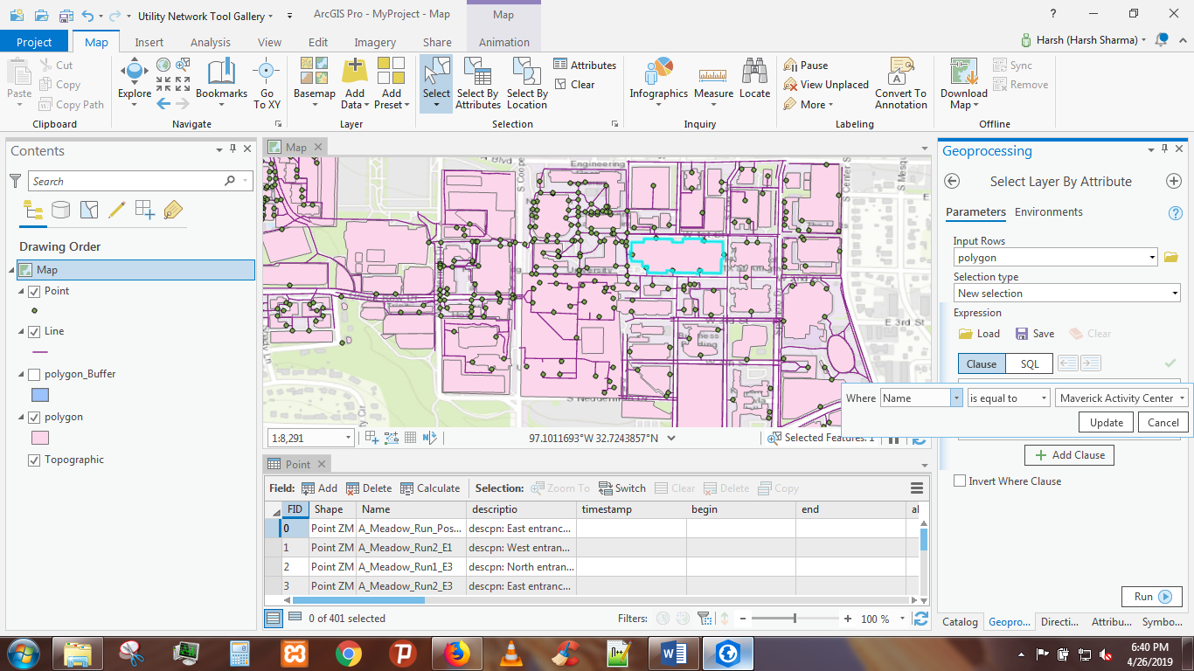

* Mavericks Activity Centre is displayed in the map as shown below.

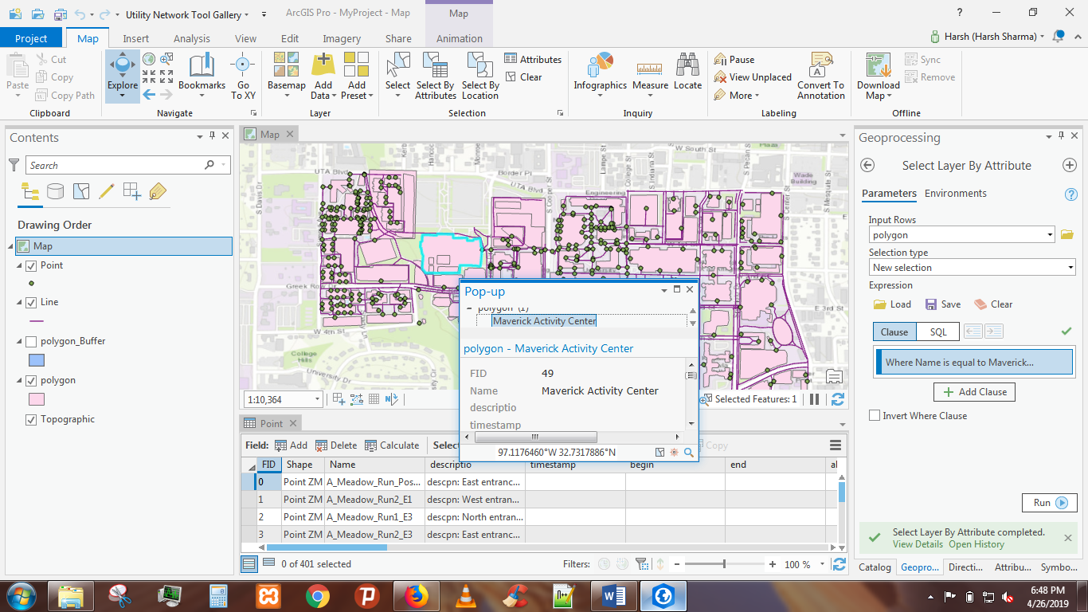

**QUERY 2**

Choose a building and a distance and return the names of all buildings or spaces of a particular type within that distance from the building (for example, find all "parking lot" type spaces within 2 miles from ERB building).

**SOLUTION**

* For this query we firstly select a building, the building selected is University Centre as shown in screenshot.

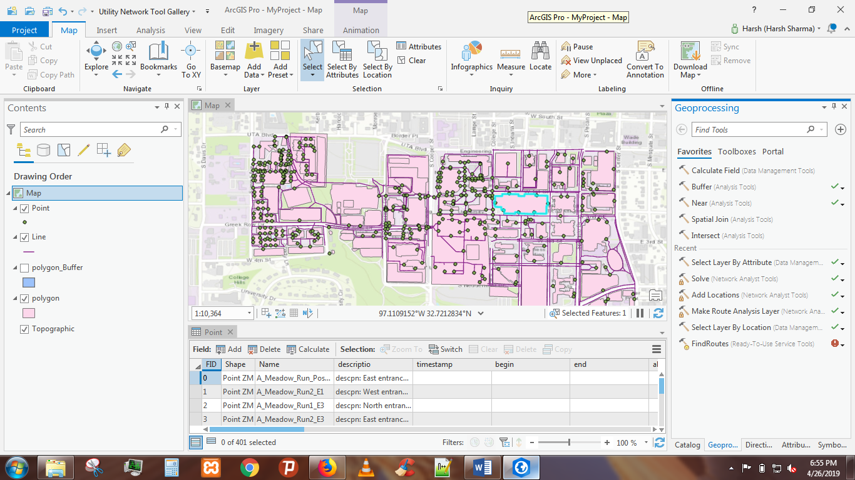

* After selecting the building we choose Select By Location tab from menu above and all the buildings that are within 200 meters of University Centre are highlighted in the map.

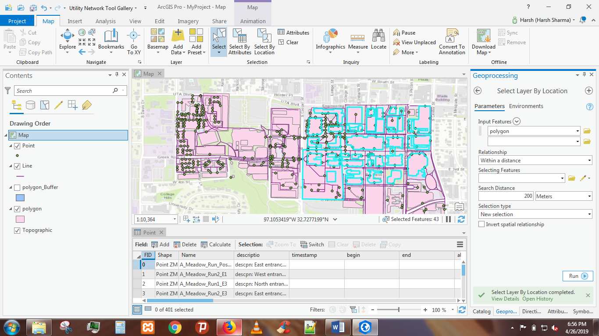

* Now, we choose Select By Attributes tab from the menu above and wrote the query to show the buildings whose Btype is Housing as shown in Screenshot.

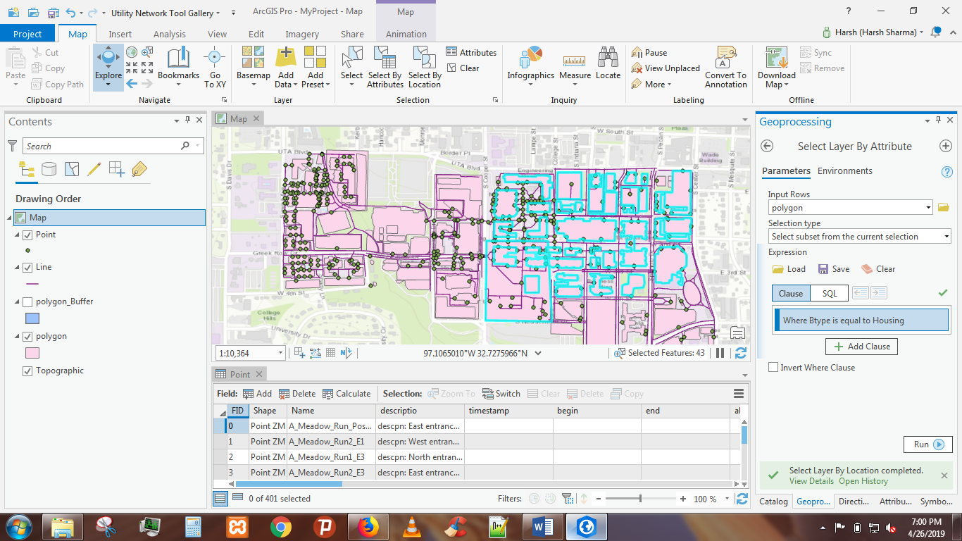

* After running the query we got the result it displayed all the buildings within 200 meters of University Centre whose Btype is Housing.

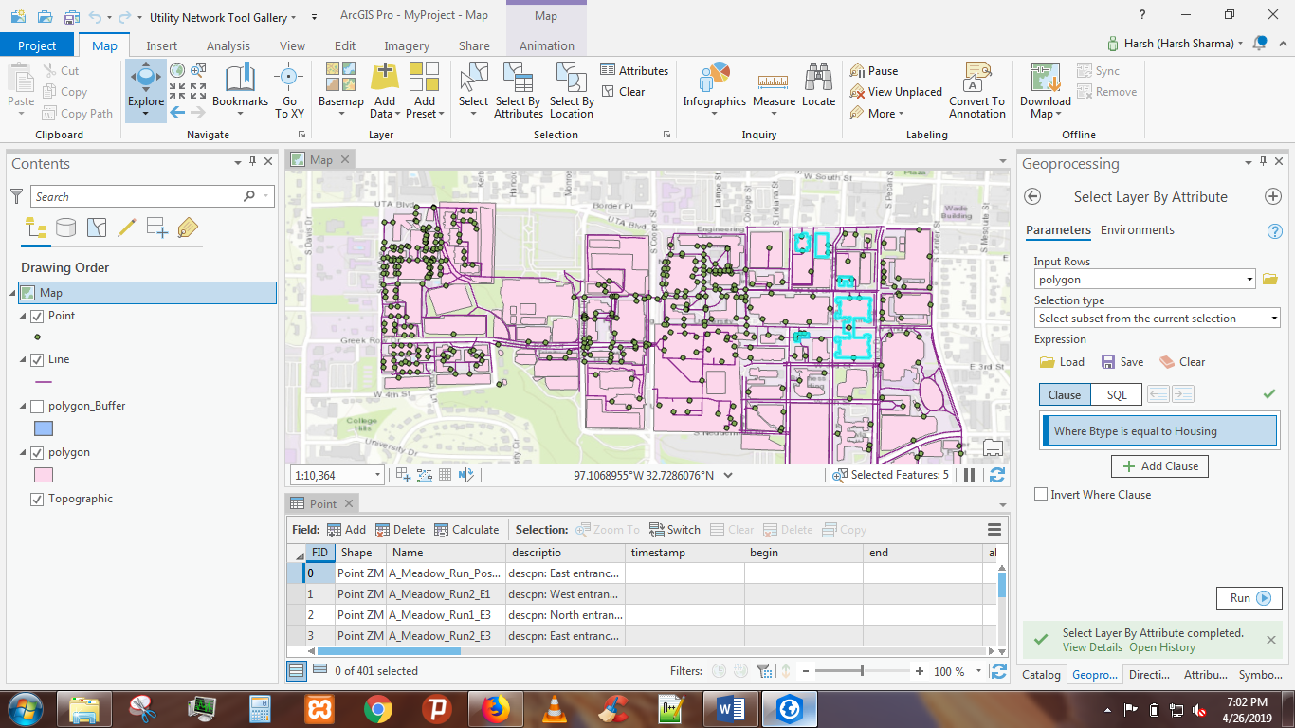

**QUERY 3**

Choose two points (building entrances) using pull-down menus (for example ERB entrance 1 and Davis Hall entrance 1) and calculate and return a path that is the shortest path between the two buildings.

**SOLUTION**

* For this query we clicked on Analysis menu in the tool and selected Route option from Network Analysis option in the tab as shown below.

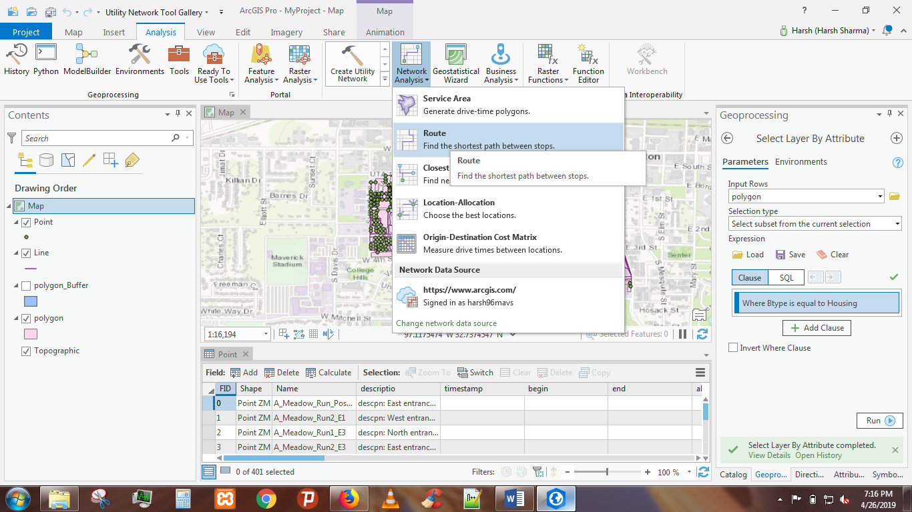

* Routes are displayed at left hand side as shown.

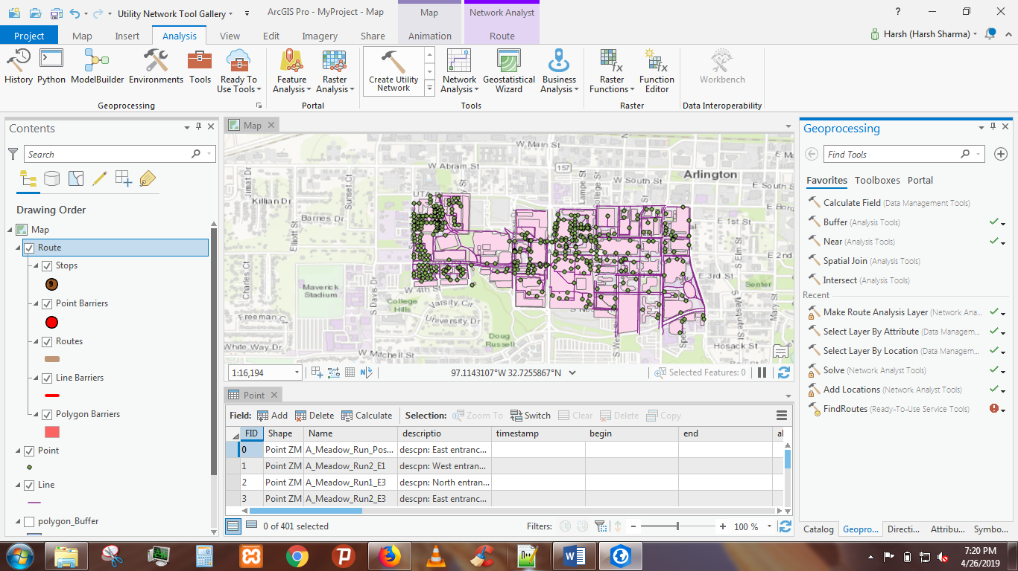

* Now, we clicked on Import Stops option on the tool to select two points in order to obtain the shortest distance between those points.

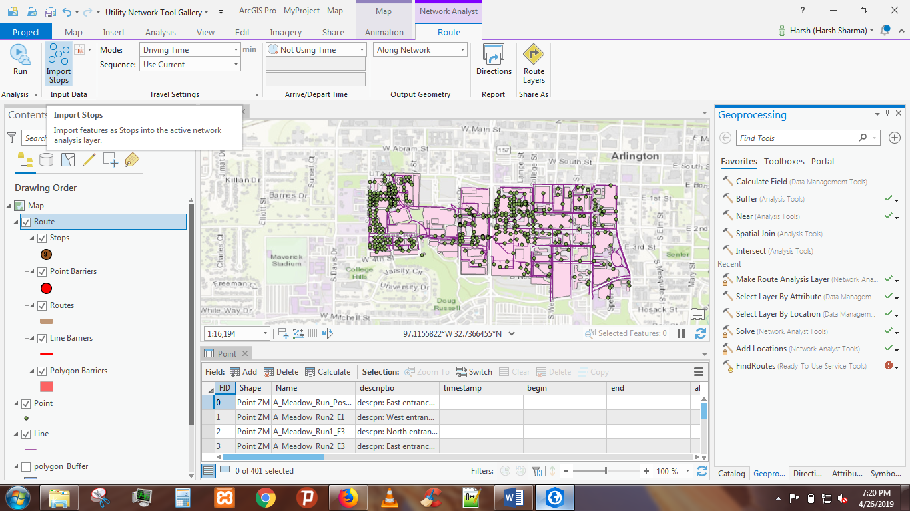

* Now here we selected two points which are shown below.

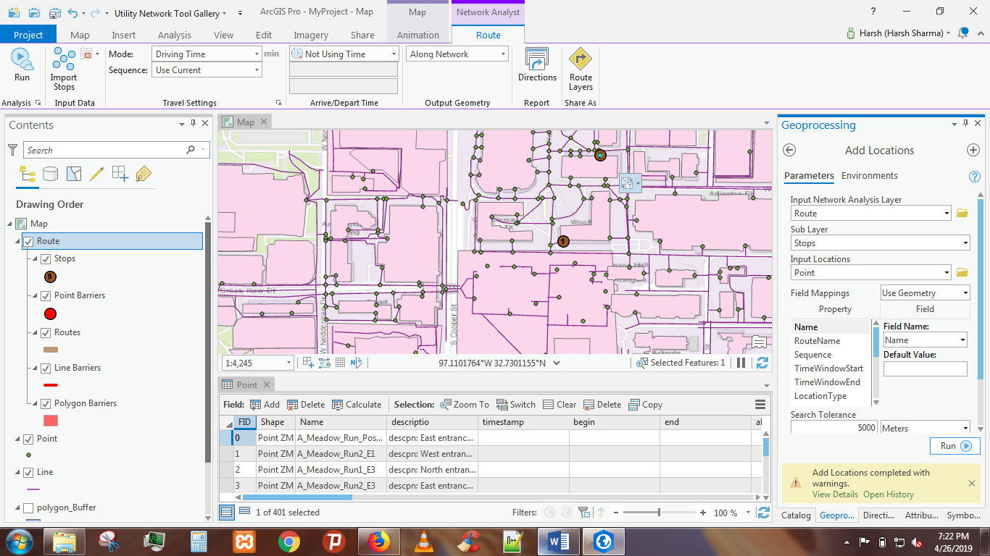

* After selecting two points, we choose mode and mode can be driving time, walking distance. Here, we selected walking distance as the mode and sequence as the Best result.

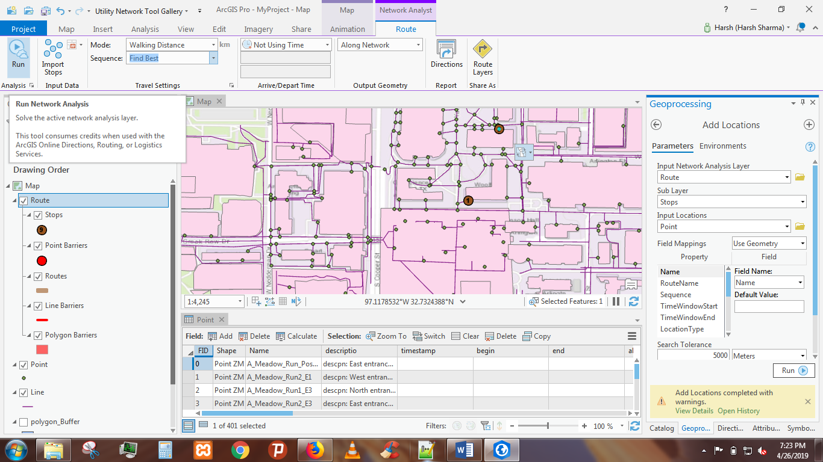

* We got the shortest walking distance with directions, distance and time estimated as shown below in the screenshot.

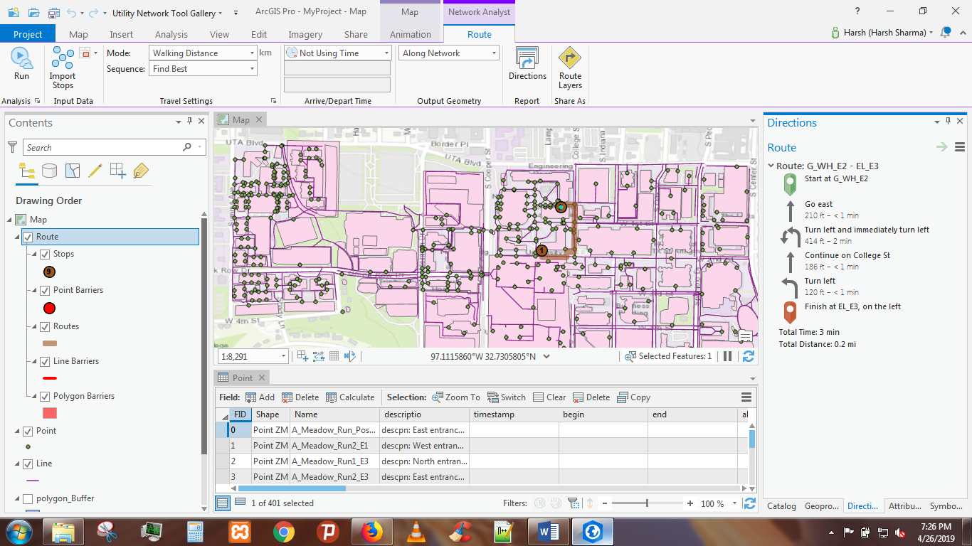

**REFRENCES**

* https://www.youtube.com/watch?v=8uAq1C7tJyU
* https://developers.google.com/kml/documentation/kml_tut
* <https://www.youtube.com/watch?v=ZI3yzAVCK_0&feature=youtu.be>
* https://desktop.arcgis.com/en/arcmap/10.4/extensions/network-analyst/exercise-3-finding-the-best-route-using-a-network-dataset.htm